21.87: a) 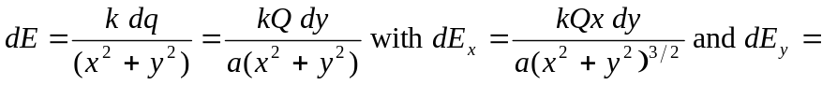
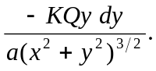 Thus:
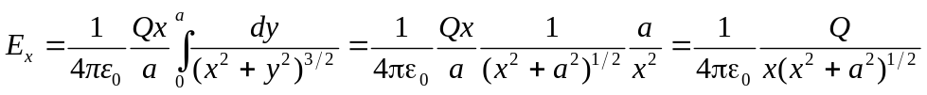
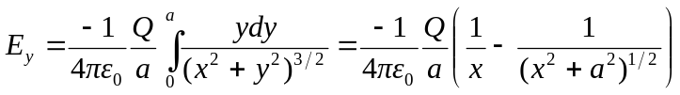
b)
c) 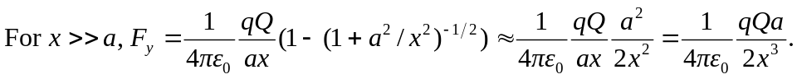
Looks dipole-like in y-direction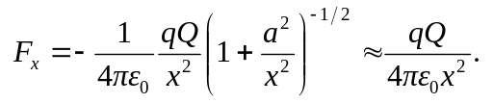
Looks point-like along x-direction

